Task 4.2

Block Diagram:
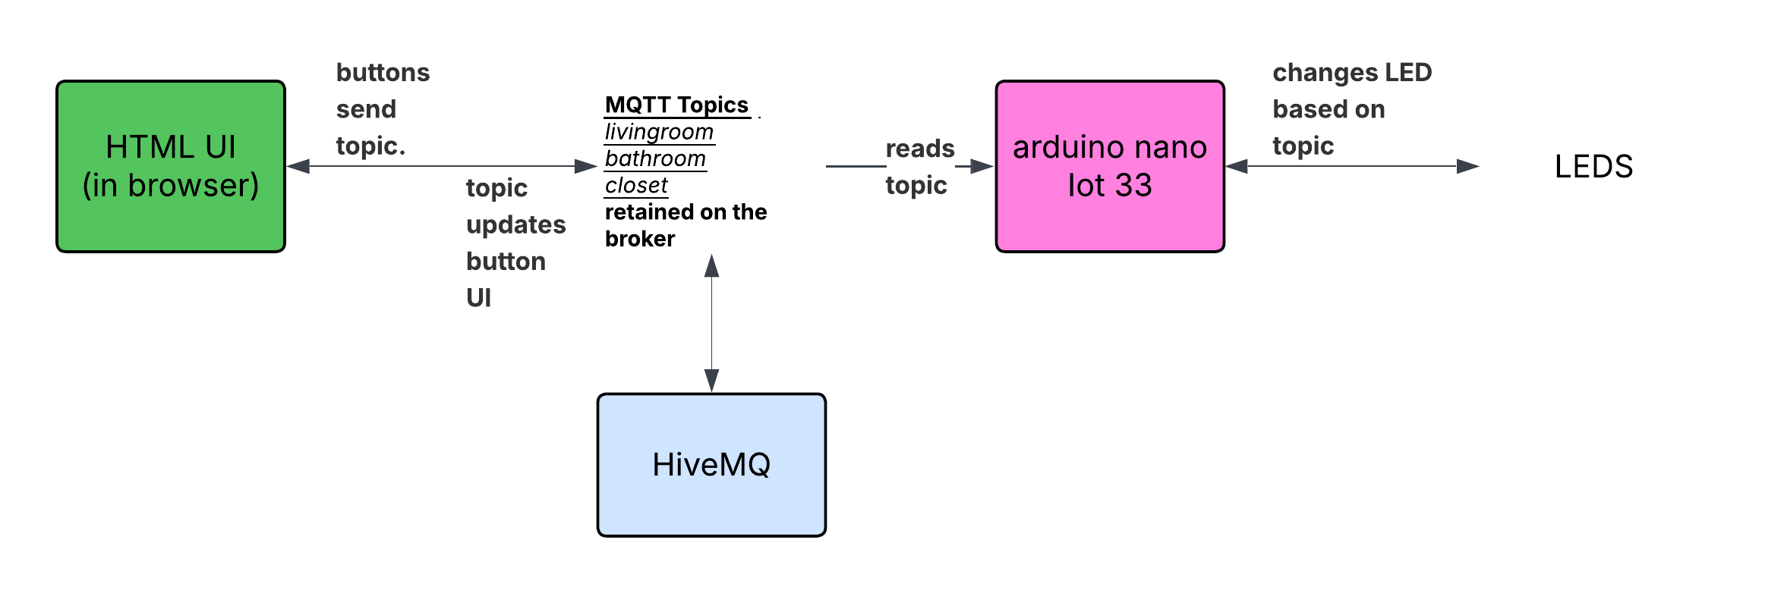

Improvements:
Used HiveMQ as the data broker instead of Arduino Cloud as it is free to use, follows the standard MQTT protocol, and does not require a paid subscription unlike Arduino Cloud's API functions.
Future improvements could include:
- A dynamic light management system that allows new lights to be added and configured directly from the HTML page without modifying the code
- User authentication to ensure only authorised carers can control the lights
- A notification system to alert carers when lights have been left on for an extended period
- Local physical light control (e.g. a wall switch) that stays in sync with the remote system
- A scheduling system to automatically turn lights off at a set time such as midnight

Links:
GitHub: https://github.com/charlieM044/SIT210/tree/main/task%204.2
Video: https://deakin.au.panopto.com/Panopto/Pages/Viewer.aspx?id=956b6b b8-bc71-46b9-989c-b41800764e8f

